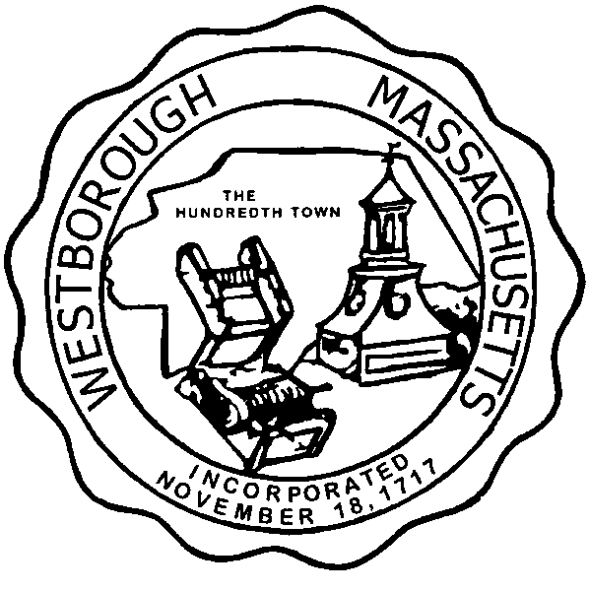

TOWN OF WESTBOROUGH

MASSACHUSETTS

Conservation Commission

Forbes Municipal Building 45 West Main St.

Westborough, MA 01581

(508) 366-3014

September 3, 2014

Ms. Wendy Mickel

Town Clerk

Westborough Town Hall

Westborough, MA 01581

Dear Wendy,

This is to inform you that the Conservation Commission will hold a meeting on Tuesday**,** September 9, 2014 at the Westborough Senior Center Meeting Room located at 4 Rogers Road, beginning at 7:00 P.M. This is the agenda for that meeting:

7:00 PM – Endorse the Certificate of Approval for the Agricultural Preservation Restriction at Glenrock Farms, Map 13, Parcels 1 & 193

7:05 PM – Hearing – Abbreviated Notice of Resource Area Delineation- Harper’s Enterprise, Inc. 50 East Main Street.

7:15 PM – Discussion – Hocomonco Pond potential reuses.

7:30 PM – Discussion – Draft revised submission protocols.

Other Business:

Approval of Minutes

Conservation Officer Updates

Report from the Property Inventory Sub-Committee

The Commission may address other business brought before them.

Respectfully Submitted,

Sheri Brown

Administrative Assistant